### UNIT-IV

### ELECTRICAL MACHINES

### THREE PHASE INDUCTION MOTOR

An electric motor is a device, which converts electrical energy into mechanical energy. Motors can operate on ac supply, single phase as well as three phase, called as ac motors.

Ac motors are further classified as synchronous motors, single phase & three phase induction motors and some special purpose motors.

Out of all these types, three phase induction motors are commonly used for various applications in industries. The principle of operation of three phase induction motors is based on the production of rotating magnetic field.

Construction of Induction Motor:

Conversion of electrical power into mechanical power takes place in the rotating part of an electric motor. In dc motors, electrical power is conducted directly to the armature (rotating part) through brushes and commutator. Hence a dc motor can be called as a conduction motor.

However, in ac motors the rotor does not receive electric power by conduction but by induction in exactly the same way as the secondary of a 2-winding transformer receives its power from the primary. That is why such motors are known as Induction motors.

An induction motor can be treated as a rotating transformer i.e., one in which primary winding is stationary but the secondary is free to rotate.

|  |  |
| --- | --- |
| Advantages | Disadvantages |
| 1. It has very simple and almost unbreakable construction | 1. Its speed cannot be varied without sacrificing some of its efficiency |
| 2. Its cost is low and it is very reliable | 2. Just like a dc shunt motor, its speed decreases with increase in load |
| 3. It has high efficiency | 3. Its starting torque is inferior to that of dc shunt motor |
| 4. It requires minimum maintenance |  |
| 5. It needs no extra starting motor for starting |  |

Construction:

An induction motor consists essentially of two main parts.

1. Stator
2. Rotor

Stator is the stationary part and rotor is the rotating part.

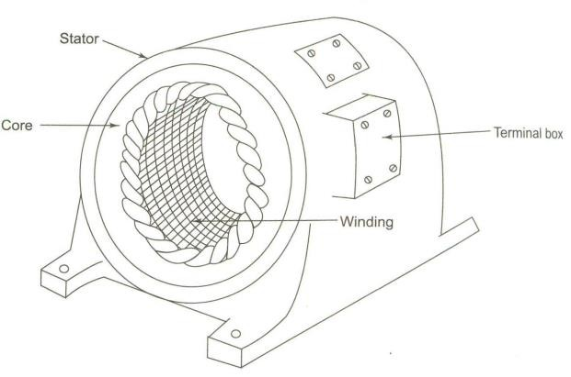

**Stator**:

Stator is made up of a number of stampings which are slotted to receive the windings. The stator carries a 3- phase winding and is fed from a 3-phase supply. It is wound for a definite number of poles, the exact number of poles being determined by the requirements of speed. Greater the number of poles, lesser the speed and vice versa. The stator windings when supplied with 3- currents produce a magnetic flux which is of constant magnitude but which revolves at synchronous-speed given by Ns=120f/p. This revolving magnetic flux induces an emf in the rotor by mutual induction.

Rotor:

1. Squirrel-Cage rotor: Motors employing this type of rotor are known as squirrel cage induction motors.
2. Phase-wound or wound rotor (**Slip-Ring rotor)**: Motors employing this type of rotor are known as phase-wound motors or wound motors or slip-ring motors.

### Squirrel-Cage Rotor:

90% of induction motors are squirrel-cage type, because this type of rotor has the simplest and most rugged construction. The rotor consists of a cylindrical laminated core with parallel slots for carrying the rotor conductors and these slots are not wires but consists of heavy bars of copper, aluminum or alloys. The rotor bars are permanently short-circuited on themselves. Hence, it is not possible to add any external resistance in series with rotor circuit for staring purposes. One bar is placed in each slot. The rotor bars are brazed or electrically welded or bolted to two heavy and stout short circuiting end rings thus giving a squirrel-cage construction.

The rotor slots are usually not quite parallel to the shaft but are purposely given a slight skew. This is useful as:

1. it helps to make the motor run quietly by reducing the magnetic hum
2. it helps in reducing the locking tendency of the rotor i.e., the tendency of the rotor teeth to remain under the stator teeth due to direct magnetic attraction between the two.

### Phase-wound Rotor (or) Slip-Ring motor:

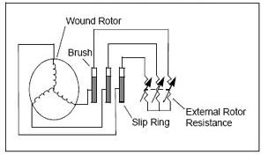

This type of rotor is provided with 3-, double-layer, distributed winding consisting of coils. The rotor is wound for as many poles as the number of stator poles and is always wound 3- phase even when the stator is wound two-phase. The three-phases are starred internally and the construction is complicated.

The slip rings are mounted on the shaft. One end of each phase winding, after connecting the winding in star or delta is connected to the slip ring. Thus there are three slip rings mounted on the shaft with brushes resting on them. These three brushes are further externally connected to three phase star connected rheostat. This makes possible the introduction of additional resistance in the rotor circuit during the starting period for increasing the starting torque of the motor. When running under normal conditions, the slip-rings are automatically short-circuited by means of a metal collar which is pushed along the shaft and connects all the rings together. Next, the brushes are automatically lifted from the slip rings to reduce the frictional losses & the wear & tear & hence under normal running conditions, the wound rotor is short-circuited on itself just like the squirrel cage rotor.

The main parts of a slip-ring motor are:

* 1. Frame-made of cast-iron
  2. Stator and Rotor core made of high quality low loss silicon steel laminations and with enhanced insulation.
  3. Stator and rotor windings- More moisture proof insulation embodying mica and high quality varnish.
  4. Shafts and bearings: Ball and roller bearings are used to suit heavy duty trouble free running.
  5. Fans: Light aluminum fans are used for adequate circulation of cooling air.
  6. Slip-rings and Slip ring enclosures: Slip-rings are made of high quality phosphor-bronze and are of moulded construction.

Principle of operation:

When the 3- stator windings are fed by 3- supply then a rotating magnetic field of constant magnitude is produced. This field rotates at synchronous speed Ns. This rotating flux cuts the rotor conductors which are stationary and due to relative speed between the rotating flux and the stationary conductors, an emf is induced in the latter according to Faraday’s law of Electro-magnetic induction.

The frequency of the induced emf is the same as the supply frequency. Its magnitude is proportional to the relative velocity between the flux and the conductors and its direction is given by Fleming’s right hand rule.

Since the rotor bars or conductors form a closed circuit, rotor current is produced in the rotor bars in case of squirrel cage or in the rotor phases in the case of slip ring whose direction as given by Lenz’s law is such as to oppose the very cause producing it.

The rotor currents and the stator magnetic field interact with each other to produce a torque and hence the rotor rotates.

Hence, the very cause of producing the current is the relative speed between the rotating field and the stationary rotor and to reduce this relative speed, the motor starts running in the same direction as that of the flux and tries to catch up.

Rotating Magnetic Field (RMF):

It is defined as the field or flux having constant amplitude but whose axis rotates in a plane at a certain speed eg. permanent magnet rotating in a space produces a rotating magnetic field. If an arrangement is made to rotate the poles, with constant excitation supplied, the resulting field is rotating magnetic field. Such a rotating magnetic field can also be produced by exciting a set of stationary coils or windings with the help of ac supply. The resultant flux produced in such a case has constant magnitude and its axis rotates in space without physically rotating the windings. The rotating flux or rotating magnetic field also bears a fixed relationship between number of poles, frequency of ac supply and speed of rotation.

*N*  120*f*

*s*

*P*

Hence rotating magnetic field always rotates with a speed equal to synchronous speed. When three phase supply is given to the stationary three phase winding, the resultant flux produced is rotating in space having constant amplitude and with synchronous speed Ns which depends on frequency of three phase supply and the number of poles for which the three phase stationary winding is wound. This flux is *rotating magnetic field*.

Production of Rotating Field:

When the stationary coils, wound for two or three phases, are supplied by two or three-phase supply respectively, a uniformly-rotating (revolving) magnetic flux of constant value is produced.

Two-phase supply:

The principle of a 2-, 2-pole stator having two identical windings 90 space degrees apart is shown:

The flux due to the current flowing in each phase winding is assumed sinusoidal and is shown below. The assigned positive directions of fluxes are shown below.

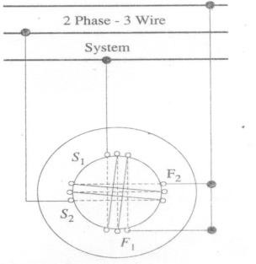

Three-phase Supply:

When three-phase windings are displaced in time by 1200, then they produce a resultant magnetic flux, which rotates in space as if actual magnetic poles were being rotated mechanically. The principle of a 3- two-pole stator having three identical windings placed 1200 space degrees apart is shown.

1200

1200

1200

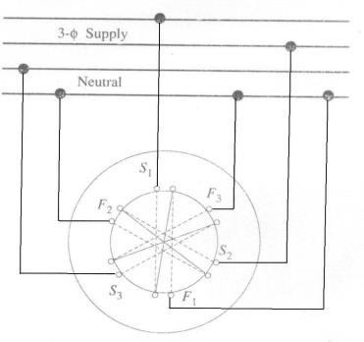

Hence, we conclude that:

1. The resultant flux is of constant value = 3/2 m i.e., 1.5 times the maximum value of the flux due to any phase.
2. The resultant flux rotates around the stator at synchronous speed given by Ns = 120 f / p

Slip:

The rotor never succeeds in catching up with the stator field because if it really did so, then there would be no relative speed, no emf, no rotor current and hence no torque. The rotor falls back behind the magnetic field by a certain speed which is necessary for the operation of an induction motor and the difference in speed depends upon the load on the motor.

The difference between the synchronous speed Ns and the actual speed N of the rotor is known as slip speed.

% slip s =

*NS*  *N NS*

Ns - N = slip speed N = Ns (1 - s)

The revolving flux is rotating synchronously relative to the stator (i.e., stationary space) but at slip speed relative to the rotor.

Frequency of rotor current:

When the rotor is stationary the frequency of rotor current is the same as the supply frequency. But when the rotor starts revolving, then the frequency depends upon the relative speed or on slip-speed.

Let at any slip–speed, the frequency of the rotor current be f. Then Ns - N = 120 f/P

Ns = 120 f/P

f/f = Ns - N/Ns = s f= sf

Motor current has a frequency of f= sf and when flowing through the individual phases of rotating winding give rise to rotor magnetic fields.

These individual rotor magnetic fields produce a combined rotating field whose speed relative to rotor is

120f/P = 120Sf/P = SNs

However, the rotor itself is rotating at speed N with respect to space. Hence speed of rotor field in space = speed of field relative to rotor + speed of rotor relative to space:

= SNs + N = SNs + Ns (1-S) = Ns

Whatever may be the value of slip, rotor current and stator currents each produce a sinusoidally distributed magnetic field of Ns.

That is, both the rotor and stator fields rotate synchronously which means that they are stationary w.r.t. each other.

**PROBLEMS:**

* 1. A 3 –phase I. M. is wound for 4 poles and is supplied from 50 Hz system. Calculate (1) Synchronous-speed (2) rotor speed, when slip is 4% (3) rotor frequency when rotor runs at 600 rpm.

Ns = 120f/P = 120 x 50/4 = 1500 rpm Ns = Ns (1-s) = 1500 (1-0.04) = 1440 rpm

When rotor speed is 600 rpm, slip is

s = (Ns – N)/Ns = (1500-600)/1500 = 0.6

Rotor current frequency f’ = sf = 0.6 x 50 = 30Hz

* 1. A 3- 6-pole 50Hz induction motor has a slip of 1% at no load and of 3% at full load. Find (A) synchronous speed (B) no – load speed (C) full-load speed.
     1. frequency of rotor–current at stand still and (E) frequency of rotor-current at full-load

P = 6, f = 50Hz S = 0.01 at no load, S = 0.03 at full load

* + - 1. Synchronous speed Ns = 120f/P = 120 x 50/60 = 1000 rpm

B) No-load speed N = Ns (1-s) = 1000 (1-0.01) = 990 rpm

C) Full load speed = N = Ns (1-s) = 1000 (1-0.03) = 970 rpm

1. At standstill, S= 1 therefore, the rotor-current frequency fr = f.S. = 50x 1=50 Hz
2. At full-load S = 0.03, fr = f S = 50 x 0.03 = 1.5 Hz
   1. A 12-pole 50 Hz 3. I. M. runs at 485 rpm what is the frequency of rotor – current.

P = 12, f = 50, N = 485 rpm

Ns = 120f/P = 120x50/P = 500 rpm

S = Ns-N = 500-485/500 = 0.03 = 3% fr = S.f. = 50 x 0.03 = 1.5 Hz

Relation between Torque and Rotor Power factor:

In case of dc motor, the torque Ta is proportional to the product of armature current and flux per pole i.e. Ta  Ia.

In case of an Induction motors the torque is also proportional to the product of flux per stator pole and the rotor current. There is one more factor that has to be taken into account i.e., the power factor of rotor.

T   I 2 cos  2

or T = K  I2 cos 2

Where I2 = rotor current at stand still

2 = angle between rotor emf and rotor current k = constant

Let the rotor emf at stand still be E2.

E2  

T  E2 I2 cos2

T = k1 E2 I2 cos2

The effect of rotor power factor on motor torque for various values of 2 is shown from the above equation of torque, it is clear that as 2 increases then cos2 decreases & hence torque decreases and vice versa.

Torque = Turning or twisting moment force about an axis.

The torque developed by the motor at the instant of starting is called starting torque.

In some cases, it is greater than the normal running torque whereas in some other cases it is somewhat less.

Let E2 = rotor emf per phase at standstill R2 = rotor resistance / phase

X2 = rotor reactance/ phase at standstill.

Z2 = R 2 + X 2 = rotor impedance / phase at standstill. I2 = E2/Z2 = E2/R 2+X 2;

2 2

2 2

cos 2 = (R2/Z2) = R2/(R 2 + X 2)

2 2

Starting torque Tst = K1 E2 I2 cos 2.

If supply voltage V is constant, then the flux  and hence E2 both are constant Tst = K2 R2/R 2 + x 2 = K2/R2 Z2 where k2 is some other constant.

2

2

Starting torque of a squirrel cage motor:

The resistance of a squirrel-cage rotor is fixed & small as compared to its reactance which is very large especially at the start because at stand till, the frequency of the motor currents equals the supply frequency. Hence the starting current I2 of the rotor though very large in magnitude lags by a very large angle behind E2, with the result that the starting torque per ampere is very poor. It is roughly 1.5 times the full load torque although the starting current is 5 to 7 times the full-load current. Hence, such motors are not useful where the motor has to start against heavy loads.

Starting torque of a slip-ring motor:

The starting torque of such a motor is increased by increasing its power factor by adding external resistance in the rotor circuit from the star connected rheostat, the rheostat resistance being progressively cut out as the motor gains speed.

Addition of external resistance, however, increases the rotor impedance and so reduces the rotor current. At first, the effect of improved power factor predominates the current- decreasing effect of impedance. Hence, starting torque is increased.

But after a certain point, the effect of increased impedance predominates the effect of improved power factor and so the torque starts decreases.

Torque – Slip Characteristics:

As an induction motor is loaded from no load to full load, its speed decreases hence slip increases. Due to increased load, motor has to produce motor torque to satisfy load demand. The torque ultimately depends on slip as explained earlier. The behavior of motor can be easily judged by sketching a curve obtained by plotting torque produced against slip of induction motor. The curve obtained by plotting torque against slip from S = 1 at start) to S =

0 (at synchronous speed) is called torque – slip characteristics of the induction motor. It is very interesting to study the nature of torque – slip characteristics.

We have seen that for a constant supply voltage E2 is also constant. So we can write torque

equations as, *T *

2

*sR*2

*R*2  *sX*2 2

Now to judge the nature of torque – slip characteristics let us divide the slip range (S = 0 to S

= 1) into two parts and analyze them independently.



Stator Current

Maximum Torque

**Torque**

T∞1/S

T∞S

Torque

S=0 Slip S=1 Speed

1. Low slip region: In low slip region, ‘S’ is very small. Due to this, the term (SX2)2 is so small as compared to R 2 that it can be neglected.

2

*T  SR*2 * S*

*R*

2

2

as R2 is constant

Hence in low slip region, torque is directly proportional to slip. So as load increases, speed decreases, increasing the slip. This increases the torque which satisfies the load demand. Hence, the graph is straight line in nature.

At N = Ns, s = 0 hence T = 0. As no torque is generated at N = Ns, motor stops if it tries to achieve the synchronous speed. Torque increases linearly in this region of low slip values.

1. High slip region: In this region, slip is high i.e. slip value is approaching to 1. Here it can be assumed that the term R2 2 is very small as compared (s X2 )2. Hence neglecting the term

R 2 from the denominator, we get,

2

*T * *SR*2 ** 1

*S X*2 2 *S*

, Where R2 and X2 are constants.

So in this region, torque is inversely proportional to the slip. Hence its nature is like rectangular hyperbola. Now when load increases, load demand increases but speed decreases. As speed decreases, slip increases. In high slip region as T  1/S, torque decreases as slip increases. But torque must increase to satisfy the load demand. As torque decreases due to extra loading effect speed further decreases and slip further increases. Again torque decreases as T  1/S hence same load act as an extra load due to reduction in torque produced. Hence speed further drops. Eventually motor comes to standstill condition. The motor cannot continue to rotate at any point in this high slip region. Hence this region is called unstable region of operations.

So torque – slip characteristics has two parts,

* 1. straight line called stable region of operation
  2. Rectangular hyperbola called unstable region of operation.

Losses in an Induction Motor:

The various power losses in an induction motor can be classified as

* + 1. Constant losses
    2. Variable losses

Constant Losses:

These can be further classified as Core losses or mechanical losses. Core losses occur in stator core and rotor core. These are also called as iron losses. These losses include eddy current losses and hysteresis losses.

The eddy current losses are minimized by using laminated construction while hysteresis losses are minimized by selecting high grade silicon steel as the material for stator and rotor.

Mechanical Losses include frictional losses at the bearings and windage losses.

Variable Losses:

This includes the copper losses in stator and rotor winding due to current flowing in the winding. As current changes when load changes these losses are said to be variable losses.

Power distribution diagram of an I.M:

M otor input in stator P 1

Stator Cu & iron losses (PCu & Pi )

rotor input or stator output (P 2)

rotor Cu loss (PCU )

M echinc al p o wer d e velo p e d, P m

or gross rotor output, Pg

win d a g e & friction loss

rotor output or m otor output (P o ut)

**Torque developed by an I.M:**

An induction motor develops gross torque Tg due to gross rotor output Pm. Its value can be expressed either in terms of rotor input P2 or rotor output Pm

Tg= P2/ws =

*p*2 in terms of rotor input 2*N*

= *pm* =

*w*

*pm*

2*N*

in terms of rotor output

The starting torque Tsh is due to output power Pout which is less than Pm because of rotor friction and windage losses.

 *Tsh*  *pout*

*w*

 *pout*

2*N*

The difference between Tg and Tsh equals the torque lost due to friction and windage loss in the motor.

Tg=

*P*2  60 *X P*2

 9.55 *P*2 *N*  *m*

2*Ns* / 60 2** *Ns Ns*

= *Pm*

 60 *X Pm*

 9.55 *Pm N*  *m*

2*N* / 60 2** *N N*

Tsh=

*Pout*

 60 *X Pout*

 9.55 *Pout*

*N*  *m*

2*N* / 60 2** *N N*

Torque, mechanical power and Rotor output:

Stator input P1 = stator output + stator losses Rotor input P2= stator output

Rotor gross output, Pm= rotor input P2 – rotor losses

This rotor output is converted into mechanical energy and gives rise to gross torque Tg

Out of this gross torque developed, some is lost due to windage and friction losses in the rotor and the rest appears as the useful or shaft torque Tsh. Let N rps be the actual speed of the rotor and if Tg is in N-m, then

Tg x 2N = rotor gross output in watts Pm

Tg=

rotor gross output in watts 2**N

→ (1)

If these were no Cu losses in the rotor, then rotor output will equal rotor input and the rotor will run at synchronous speed,

rotor input P2

Tg=

2*Ns*

→ (2)

From (1) and (2), we get

Rotor gross output Pm= Tg 2N

Rotor input = P2= Tgws= Tg x 2Ns  (3) The difference of the two equals rotor Cu loss.

 rotor Cu loss = P2 - Pm = T x 2(Ns – N)  (4)

Form (3) and (4)

Rotor Cu loss  *Ns*  *N*  *S*

Rotor input *Ns*

rotor Cu loss = S X rotor input

= S X power across air gap = SP2

Rotor input =

rotor Cu loss S

Rotor gross output Pm= input P2- rotor Cu loss

= input – S X rotor input

= (1-S) input P2

rotor gross output Pm= (1-S) rotor input P2

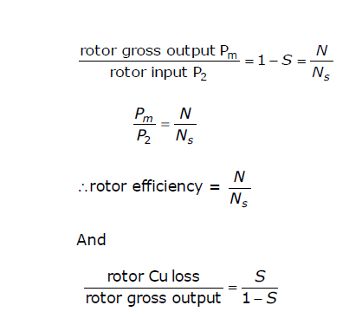

If some power P2 is delivered to rotor, then a part SP2 is lost in the rotor itself as copper loss and the remaining (1-S) P2 appears as gross mechanical power Pm

P2: Pm : I2R : 1: (1-S) : S

Or P2: Pm : Pc : 1: (1-S) : S

The rotor input power will always divide itself in this ratio, hence it is advantageous to run the motor with as small ship as possible.

Problems:

1. The motor emf of a 3-, 6-pole, 400V, 50 Hz I.M alternates at 3Hz. Compute the speed and percentage slip of the motor. Find the rotor Cu loss per phase if the full input to the motor is 119.9 kw.

S= *fr f*

 3  0.06

50

or 6%

Ns=120 *X* 50  1000

6

rpm

N= (1-S) Ns = (1-0.06) 1000= 940 rpm

Rotor input = 111.9 kw

Rotor Cu loss= s X rotor input

= 0.06 X 111,900

= 6715 w

loss/phase=6715  2238*w*

3